**CAUSES AND PREVENTION OF ROAD TRAFFIC CRASH**

Paper Presentation

At

**The 2024 Federal Road Safety Corps (FRSC) Mandatory Training Workshop for Drivers**

By

**A Idris**

Route Commander

31-10-2024

**Introduction**

Road traffic crashes (RTCs) remain a significant public health and safety concern in Nigeria, with thousands of lives lost annually and many more injured. These accidents are often preventable and stem from a variety of factors that can be categorized into environmental, mechanical, and human causes. The implications of road traffic crashes are severe, affecting individuals, families, the economy, and the nation at large. Therefore, understanding the causes of RTCs and implementing effective prevention measures are critical to reducing the incidence of these accidents.

In this paper, we will examine the causes of road traffic crashes, their implications, and strategies for preventing them. Special attention will be given to the recent rise in the number of trailers diverting through Offa Township and how drivers can prevent potential related dangers.

**Classification of Causes of Road Traffic Crashes**

**1. Environmental Factors**

Environmental conditions play a significant role in road traffic crashes. These include:

**Weather Conditions**: Heavy rain, fog, and dust storms reduce visibility, making it difficult for drivers to see the road and other vehicles. Wet or slippery roads can lead to a loss of control, causing accidents.

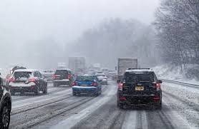

**Road Infrastructure**: Poorly maintained roads, potholes, lack of proper road markings, and inadequate signage can contribute to accidents. In some areas, narrow roads and sharp bends increase the risk of head-on collisions.



**Lighting Conditions**: Poor lighting at night or in low visibility conditions can obscure hazards on the road, such as debris, pedestrians, or animals, leading to crashes.



**Traffic Congestion**: Overcrowded roads, especially in urban areas, increase the likelihood of rear end collisions and fender benders due to sudden stops and start movements.

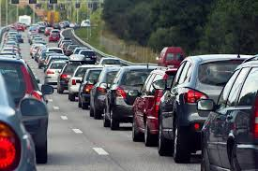

**2. Mechanical Factors**

Mechanical failures in vehicles are a common cause of road traffic accidents. Some of the most frequent mechanical issues include:



**Brake Failure**: Faulty or worn out brakes reduce the ability to stop the vehicle quickly in emergencies, leading to collisions.

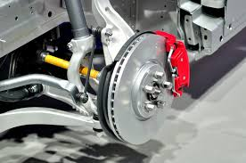

**Tire Blowouts**: Tires that are underinflated, worn, or damaged can burst, causing the driver to lose control of the vehicle.

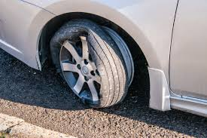

**Steering and Suspension Issues**: Problems with the steering system or suspension can affect the driver’s ability to control the vehicle, especially at high speeds.

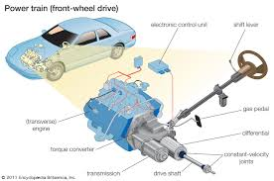

**Engine and Transmission Failures**: These can lead to sudden stalling or power loss, particularly dangerous when driving at high speeds or on busy roads.

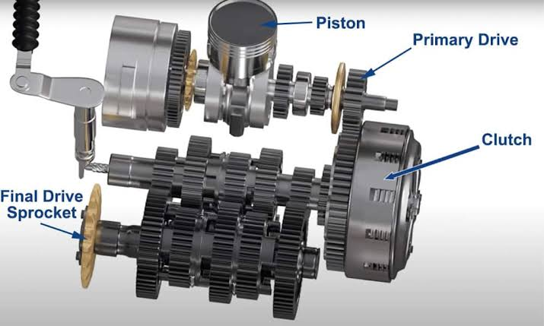

**Lighting System Failures**: Broken headlights, brake lights, or turn signals reduce visibility for both the driver and other road users, increasing the risk of accidents.



**3. Human Factors**

Human error remains the leading cause of road traffic crashes. Some of the most common human related factors include:

**Speeding**: Driving above the speed limit reduces the driver’s ability to react to hazards, increases stopping distance, and raises the severity of crashes.



**Distracted Driving**: Use of mobile phones, eating, or talking to passengers while driving diverts attention from the road and is a major cause of accidents.



**Driving Under the Influence of Alcohol and Drug**: Alcohol and drug impairment significantly reduce reaction times, judgment, and coordination, making it more likely for drivers to cause crashes.

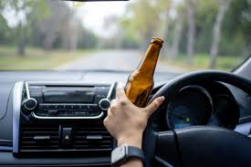

**Fatigue**: Drowsy driving is as dangerous as drunk driving. Drivers who fall asleep or become too tired to react properly are prone to accidents.



**Reckless and Aggressive Driving**: Tailgating, sudden lane changes, running red lights, and other forms of aggressive driving behavior increase the likelihood of accidents.



**Implications of Road Traffic Crashes**

The implications of road traffic crashes are far reaching and affect various aspects of society:

1. **Loss of Lives and Injuries**: According to the Federal Road Safety Corps (FRSC), Nigeria recorded over 10,000 road traffic crashes in 2022, leading to 6,205 deaths and 27,112 injuries. These statistics highlight the high human cost associated with traffic crashes.



1. **Economic Costs**: The economic impact of road accidents is significant. Medical bills, vehicle repairs, lost productivity, and insurance claims place a heavy financial burden on individuals, businesses, and the government. Nigeria loses about 3% of its GDP annually due to road accidents.



1. **Psychological Trauma**: Survivors of road crashes, as well as families of victims, often experience long term psychological trauma. Grief, post traumatic stress disorder (PTSD), and depression are common among those affected.



1. **Impact on Infrastructure**: Road crashes can cause damage to public infrastructure such as road barriers, traffic lights, and bridges, requiring costly repairs.

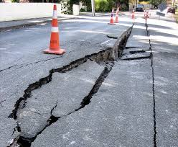

**5. Traffic Disruptions**: Crashes often result in road closures or traffic jams, causing delays and additional costs for businesses and commuters.



**Prevention of Road Traffic Crashes**

Preventing road traffic crashes requires a combination of government action, driver responsibility, and proper vehicle maintenance. Below are some strategies that can help reduce the risk of accidents:

**1. Environmental Measures:**

**Improved Road Design and Maintenance**: Governments must invest in constructing and maintaining roads with proper markings, signage, and lighting. Potholes and dangerous curves should be repaired or made safer.

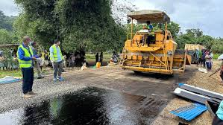

**Traffic Management**: Installing speed bumps, roundabouts, and traffic lights at key points can help control vehicle flow and prevent accidents in congested areas.

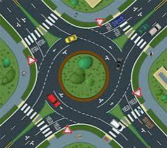

**Weather Warnings and Precautions**: Drivers should get information about adverse weather conditions through radio alerts, road signs, and other communication channels, so they can adjust their driving accordingly.



**2. Mechanical Measures:**

**Regular Vehicle Maintenance**: Drivers must ensure their vehicles are regularly serviced, with special attention given to the brakes, tires, steering and lights. Preventive maintenance reduces the risk of mechanical failures.

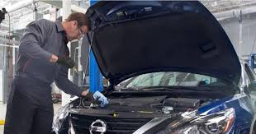

**Pre-Trip Inspections**: Before embarking on any journey, drivers should conduct basic vehicle checks, including tire pressure, oil levels, and brake function.

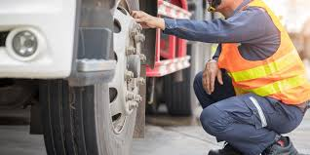

**3. Human Factor Measures**:

**Adhering to Speed Limits**: Drivers must obey speed limits and adjust their speed according to road and traffic conditions.



**Avoiding Distractions**: Drivers should refrain from using mobile phones or engaging in other distracting activities while driving.



**Alcohol and Drug Education**: Public awareness campaigns highlighting the dangers of driving under the influence of intoxicants should be intensified, and stricter penalties should be enforced for offenders.

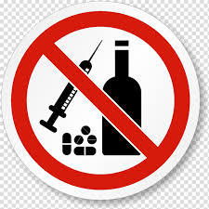

**Combating Fatigue**: Drivers, particularly commercial drivers, should get adequate rest and avoid driving when fatigued.



**Managing Traffic along Offa Township Road: Preventing Possible Dangers from Trailers**

With the increase in trailers diverting through the town currently, drivers need to take extra precautions to avoid accidents, given the size and potential hazards of these heavy duty vehicles. Here are some preventive measures:

**1. Maintaining a Safe Distance**:

Always keep a safe distance when following trailers. These vehicles have larger blind spots and require longer distances to stop. Staying at least 3 seconds distance behind a trailer ensures you have enough time to react if the trailer stops suddenly.

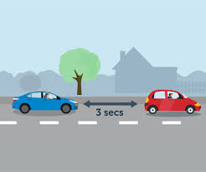

**2. Avoiding Blind Spots**:

Trailers have significant blind spots, particularly on their sides and rear. Make sure you are visible to the trailer driver by avoiding driving in these areas for extended periods.

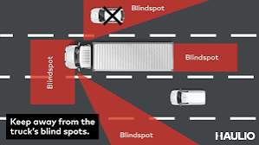

**3. Passing Safely**:

When overtaking a trailer, do so swiftly and safely. Signal early, accelerate steadily, and pass quickly. Do not linger alongside the trailer, as sudden lane changes by the trailer could cause a collision.

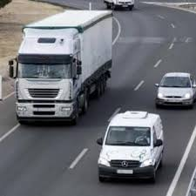

**4. Anticipating Turns:**

Trailers require wide turns, particularly when turning right. If you are driving next to a trailer as it approaches a turn, slow down and give the trailer enough room to complete the maneuver.

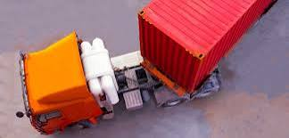

**5. Being Cautious Around Unstable Loads:**

Some trailers may be overloaded or improperly loaded, increasing the risk of accidents if the cargo shifts or falls. Keep a safe distance and report any trailers that appear unstable.

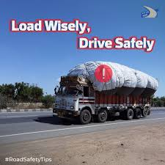

**Conclusion**

Road traffic crashes remain a major threat to public safety in Nigeria, with environmental, mechanical, and human factors contributing to the high accident rate. The implications of these crashes are severe, from loss of lives to significant economic and social costs. Preventive measures, including proper road maintenance, vehicle care, and responsible driving, are essential to reducing the frequency and severity of crashes. In the specific case of trailers on Offa road, drivers must be especially cautious and employ defensive driving techniques to prevent possible dangers. Preventing road traffic crashes is not just the responsibility of the government but a collective duty of all road users.

**References**

Federal Road Safety Corps (FRSC). (2023). **Annual Road Traffic Crash Report**. Available at: https://www.frsc.gov.ng

World Health Organization (WHO). (2022). **Global Status Report on Road Safety**. Available at: https://www.who.int

National Bureau of Statistics (NBS). (2023). **Road Transport Data: Nigeria**. Available at: https://www.nigerianstat.gov.ng